Shared Task Coordination Service (STCS)
Project: Phase 1 Report
Student: Sai Praneeth Bhattu
Course: CIS 527 - Computer Networks
Due Date: 09/18/2026

Table of Contents Page
1. Curiosity Report 3
1.1 Problem 3
1.2 Curiosity Questions 3
1.3 Target Users 3
1.4 User Stories 4
1.5 Value Proposition 4
1.6 Assumptions, Risks, Open Questions 4
2. Project Proposal 5
3. Functional Requirements 6
4. Nonfunctional Requirements 7
5. Architecture Diagram 7
6. Sequence Diagrams 8
6.1 Adding a task (valid, then invalid) 9
6.2 Phase 3 conflict - two clients claim the same task 9
7. Protocol Specification - STCS - P1 10
7.1 Framing 10
7.2 Encoding and limits 11
7.3 Message envelope 11
7.4 Session states 12
7.5 Commands 12
1. HELLO 12
2. HELP 12
3. LIST TASKS 13
4. CREATE TASK 13
5. CLAIM TASK 13
6. RELEASE TASK 14
7. COMPLETE TASK 14
8. DELETE TASK 14
9. QUIT 15
7.6 Error codes 15
8. Data Design 16
9. Initial Test Plan 17
10. Contribution Plan (Individual) 19

1. Curiosity Report

1.1 Problem
For small student groups collaborating on a common assignment, there should be only one answer to two critical questions: what has not been done yet and who is responsible for it? This answer is contained in group chats, common documents or in memory of participants. Consequently, duplication of efforts (two students write the same part) and omission of work (everyone thinks that somebody else did it) happen.
The problem is not in the absence of applications for tracking to-dos. The problem is with tools being used by groups.
Current approach | Limitation
Group chat | Chronological, not stateful - status must be reconstructed by scrolling
Shared document | Free form concurrent edits duplicate or overwrite lines
Trello / Asana / Notion | Capable, but accounts, invites and setup often aren't worth it for a 5-week project
Private notes | Invisible to teammates - the main source of duplicated effort

Regardless of why different people in this group use their machines at different times, the shared list needs to be stored somewhere that both can access. Reasons why having one centralized managed state of the server with one definitive copy is a good idea: everyone sees the same thing as verification is centralized and there is one definitive answer to the question of who claimed it first. TCP command messages cannot be out of order or lost (an ignored "add task" results in wasted effort) and reasons why we need a session lifecycle at all.

1.2 Curiosity Questions
# | Question | What I concluded | Status
1 | What outcome is the group after? | Confidence about ownership, not just a list of work | Scenario analysis
2 | What is the smallest feature set still worth using? | Identify yourself, add, list, claim, complete, delete | Design decision
3 | What must be shared vs. private? | All task data is shared only the session (name, socket, state) is private | Design decision
4 | What happens if two people claim the same task at once? | Server must serialize first successes, second gets a CONFLICT error | Design decision
5 | Must tasks survive a server restart? | Not required - tasks only need to outlive a client session | Open (Q1 below)
6 | Should a claim be freed when its owner disconnects? | Undecided for now claims stay and anyone can release them | Open (Q2 below)
7 | What would make a user stop trusting it? | Displayed state not matching reality, or a “success” that didn't commit | Design interpretation
8 | Is a terminal interface usable by non-programmers? | Only if it prompts for each field and help always works | Assumption to test
9 | What changes from 3 users to 100? | Thread count and a single lock become the limits (see 9) | Analysis
10 | Do users expect push notifications? | Pull-on demand is enough for this need push is future work | Assumption to test

1.3 Target Users
Primary - The students exchange a graded homework assignment within small groups (2-6 people). Objectives: to know what needs to be done, to stake their claim to it and to signal completion. Issues: looking through the chat history to check on the status of the project and discovering the duplication of effort later. Technical background: able to execute the specific terminal command, but not programmers. Accessibility requirements: pure text output without colors and timed messages; output must fit into 80 columns. Requirements for the commands: intuitive interface and tolerant input.
Secondary - It is desirable for the informal group coordinator to see the full list and unblock the blocked assignments. The instructors and teaching assistants get indirect help from organized groups but have no use for them directly.

1.4 User Stories
As a student working on a group assignment, I would like to create a task that other members will know about without having to communicate.
As a student beginning a task, I would like to claim an existing task to ensure that I am not repeating myself.
As a member logging into my account, I would like to be able to see all the tasks that include their owners and statuses to be able to take an unclaimed one without having to ask.
As a student who has completed a task, I would like to point out it has been done so that other members have the updated information.

1.5 Value Proposition
Small groups of students who must complete a graded assignment are provided with a terminal service by STCS. A single server holds the list of assignments which members can assign to themselves, claiming ownership and marking them as completed. It is different from group messaging or shared documents because ownership becomes an explicit status managed by the server.

- Function: Keep one official to-do list, which can be updated by multiple computers.
- Experience: Instead of a chat and waiting, use one command to ask, "who is doing the methodology?"
- Integrity: Keep one copy of data at one place. Validates a response to be correct only after the change has been committed; detects but does not ignore any conflict.
- Scalability: Each extra connected user increases the value of list, because ownership cues work only when seen by other users.

1.6 Assumptions, Risks, Open Questions
Assumptions (stated as assumptions, not facts)
- A1 users can open a terminal and run a provided command.
- A2 clients and server can reach each other over TCP (localhost or LAN).
- A3 the group is small and the list holds tens of tasks, not thousands.
- A4 members are cooperative, so no authentication is needed for a classroom demo.
Risks
Risk | Prob. | Impact | Mitigation
TCP framing bug (assuming one send = one recv) | High | High | Build framing as a separate, unit-testable module first test by splitting a message byte-byte and by sending two messages in one write - no sleep ()
Race condition on the shared task list | Medium | High | One shared structure, one lock the status check and the write happen inside the same critical section
Scope creep (deadlines, persistence, notifications) | Medium | High | One distinctive feature only (claim) explicit exclusion list
Client disconnects abruptly, leaving a dangling session | Medium | Medium | Cleanup in a final block lock never held during socket I/O
Solo schedule slip | Medium | High | Freeze Phase 2 as a working deliverable before starting Phase 3

Open questions
- Q1 Should tasks survive a full server restart? (In-memory for now file persistence is future work.)
- Q2 Should a claimed task be freed automatically when its owner disconnects? (For now, claims persist and anyone may release them.)

2. Project Proposal
Name: Shared Task Coordination Service

Statement of problem:
Students collaborate on an assignment that is assigned to their group. Currently, collaboration takes place using chat, documents and memory. However, none of them indicates what tasks are present, who is responsible for completing each task, or what tasks have been completed. As a result, there is duplication of tasks by groups, as well as unattended tasks. Collaboration by members takes place at different times and from different machines, therefore, collaboration needs to take place through a networking application with an official task list.

Target users:
Primary: Students within 2-to-6-member group
Secondary: Coordinator of the group and instructor’s scope

In scope TCP client and server custom newline-delimited JSON protocol session handshake with a display name add / list / claim / complete / delete tasks server-held shared task list structured success and error responses timestamped server log graceful and abrupt disconnect handling one thread per client with a single lock in Phase 3.

Out of scope GUI or web frontend mobile app REST/HTTP or any networking framework email or push notifications OAuth or real authentication databases or cloud deployment deadlines, subtasks, comments, search, undo, activity history server-initiated messages.

Why excluding a GUI or HTTP framework would hide the socket and framing code the project exists to demonstrate authentication and persistence are substantial subsystems that compete with the framing and concurrency work the remaining features add data model complexity without adding networking content.

Phase 2 (one client, one server) connect to a configurable host and port · HELLO session identification · add a task · list tasks · claim a task · complete a task · delete a task · HELP · QUIT · shared server-side state · structured success/error responses · framing that survives partial and coalesced reads · server log · graceful disconnect.

Phase 3 (multiple clients) one thread per client · unique session ID per connection · at least three simultaneous clients · one lock guarding the task list · a change by one client visible to the others · simultaneous claims produce exactly one success and one CONFLICT · one client's malformed input or disconnect doesn't affect the others · per-session cleanup · session-tagged logging.

Distinctive feature - Task Claim / Ownership
Any user that is online can perform the task in the OPEN state. Their display name will be saved by the server and the task status will become CLAIMED and now all the other clients know who performed it. This algorithm was selected for this problem, which is the only type where shared state is inherent and therefore synchronization should be implemented properly from the start.

Expected client-server interaction:

1. Client begins by validating the host and port.
2. Client creates a TCP socket, attempts connection and displays any errors in clear language.
3. The server accepts the connection request, generates a session ID and logs the connection.
4. The client sends HELLO with their display name; the server validates the name and responds thus the session is marked READY.
5. The client sends a command on one JSON line.
6. The server stores the data in a buffer and reads lines from it.
7. The server validates the envelope, the command and the fields.
8. The server executes the specified action.
9. The server updates the shared list (while holding the lock acquired in phase 3).
10. The server returns an answer and logs it.
11. The client displays the answer.
12. Continue.
13. Client sends QUIT.
14. The server answers, closes the socket, releases the session and keeps listening.

In Phase 3 the accept loop spawns a thread per connection instead of serving one inline the protocol and the client do not change.

3. Functional Requirements
ID | Requirement | Priority | Verification
FR-01 | The server shall listen on a TCP port supplied at startup, with no hard-coded port. | Must Have | Start on two different ports connect to each
FR-02 | The client shall connect to a hostname/IP and port supplied at startup. | Must Have | Connect via localhost and a LAN IP
FR-03 | The client shall report a failed connection in plain language without crashing. | Must Have | T-07, T-08
FR-04 | The server shall assign each connection a unique session ID and return it in the HELLO response. | Must Have | Connect 3 clients confirm 3 distinct IDs
FR-05 | The client shall send HELLO with a display name as its first message and the server shall reject any other command before it with INVALID_STATE. | Must Have | Send LIST_TASKS before HELLO
FR-06 | The server shall create a task from CREATE_TASK, assign a unique task_id, set status OPEN and return the task. | Must Have | T-02
FR-07 | The server shall return all tasks with task_id, title, priority, status and claimed_by in response to LIST_TASKS. | Must Have | T-03
FR-08 | The server shall set a task to CLAIMED with the requester's name in response to CLAIM_TASK, only if it is currently OPEN. | Must Have | T-04, T-11
FR-09 | The server shall reject CLAIM_TASK on a task that is not OPEN with CONFLICT, naming the current owner, without changing the task. | Must Have | T-11
FR-10 | The server shall set a task to DONE in response to COMPLETE_TASK and reject a task already DONE with CONFLICT. | Must Have | T-04
FR-11 | The server shall remove a task in response to DELETE_TASK, after which it no longer appears in LIST_TASKS. | Must Have | T-04
FR-12 | The server shall maintain the task list for the lifetime of the server process, independent of any client session. | Must Have | Add a task, quit, reconnect, list
FR-13 | A change committed by one client shall be visible to every other connected client on its next LIST_TASKS, with no client-side caching. | Must Have | T-10
FR-14 | The server shall respond to an unknown command with UNKNOWN_COMMAND and continue serving the connection. | Must Have | T-05
FR-15 | The server shall respond to a missing required field with MISSING_FIELD naming the field and to an invalid value with INVALID_FIELD, without changing state. | Must Have | T-06
FR-16 | The server shall respond to a line that is not valid JSON, or is empty, with INVALID_MESSAGE and keep the connection open. | Must Have | T-06
FR-17 | The server shall respond to an operation on a non-existent task_id with NOT_FOUND. | Must Have | T-06
FR-18 | The client shall provide QUIT, which sends a QUIT request, closes the socket and exits with a confirmation. | Must Have | T-04
FR-19 | The server shall release a session's resources on both graceful and abrupt disconnection and continue accepting connections. | Must Have | T-09
FR-20 | The server should serve at least three simultaneously connected clients. | Must Have | T-10
FR-21 | A malformed message or failure in one session shall not terminate the server or affect other sessions. | Must Have | T-12
FR-22 | The server shall log, with timestamps startup, listening port, each connection with session ID, each command and its outcome, each error code, each disconnection and shutdown. | Must Have | Inspect the log after a full run
FR-23 | The client shall list its supported commands when the user types help. | Must Have | Type help
FR-24 | The server shall return a CLAIMED task to OPEN in response to RELEASE_TASK. | Should Have | Claim then release
FR-25 | The client shall validate input (non-empty title, integer task ID, valid priority) before sending. | Should Have | Enter an empty title
FR-26 | The server shall allow LIST_TASKS to be filtered by status. | Could Have | List with status=OPEN
FR-27 | The server shall restore the task list from a file on startup. | Future Work | -
FR-28 | The server shall push updates to clients without a request. | Future Work | -

4. Nonfunctional Requirements
ID | Requirement
NFR-01 | The server shall continue processing subsequent requests after receiving an unsupported command from a connected client.
NFR-02 | A malformed or oversized message from one client shall not terminate the server process.
NFR-03 | For 20 repeated trials of two clients claiming the same task simultaneously, exactly one shall receive OK and the other CONFLICT and the task shall end with exactly one owner.
NFR-04 | No response shall report OK for an operation whose change was not committed to the shared list.
NFR-05 | The client shall display the list of supported commands when the user requests help, without needing a server connection.
NFR-06 | Every error shown to the user shall include a human-readable sentence in addition to the error code and shall contain no stack trace, file path, or line number.
NFR-07 | Invalid input at a client prompt shall cause a re-prompt naming the expected format and shall never terminate the client.
NFR-08 | With up to 3 clients and up to 200 tasks, the server shall return a response within 100 ms of receiving a complete request, on localhost.
NFR-09 | The client shall detect an unreachable server and report it within 10 seconds rather than blocking indefinitely.
NFR-10 | The server shall support at least three simultaneously connected clients in Phase 3.
NFR-11 | Per-client memory shall be bounded by a receive buffer of at most 8 KiB plus the session record, so memory grows linearly with the number of clients.
NFR-12 | Networking, framing, protocol validation, application logic, data, user interface and logging shall each reside in a separate module.
NFR-13 | The framing layer shall be testable without a socket, through an interface that accepts arbitrary byte chunks and emits complete messages.
NFR-14 | The server shall validate the type, length and range of every received field before use and shall reject any line longer than 8192 bytes.
NFR-15 | Display names shall be documented as identification only, not authentication.
NFR-16 | All client output shall be plain text within 80 columns, with no information conveyed only by colour and no prompt shall expire.

5. Architecture Diagram
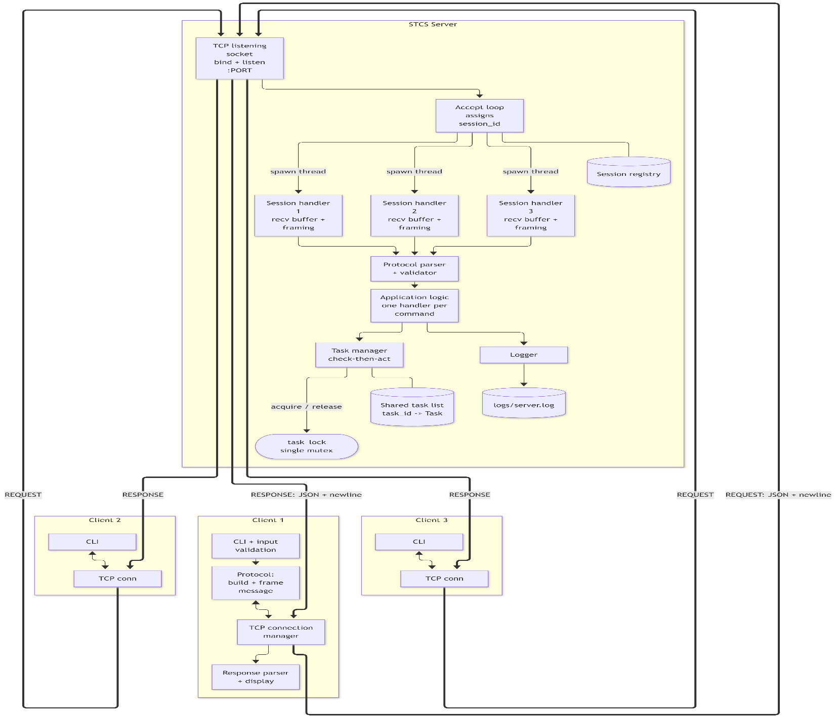
Concurrency (Phase 3): one thread per client. The main thread is responsible for accepting connections only. For each connection, there is a dedicated thread executing the same handler loop as in Phase 2. Therefore, Phase 3 uses one extra thread and one extra lock compared to Phase 2 but does not imply design changes. Preferred over a thread pool and async I/O due to visibility of the socket API in the source code, identical Phase 2 code and availability of three to ten threads on the OS level.
Each client has a thread that has exclusive access to the socket associated with this client, receives buffer and protocol state information.
The shared parts of the implementation are the task list (and ID counter), the session registry and the log sink.
Locking: task_lock is acquired only in the task manager module and both the status check and write occur in the same critical section. session_lock is guarding the session registry. The logger serializes write operations. Deadlocks are impossible since there are no code paths acquiring multiple locks or performing any socket I/O, disk I/O, or user input within a critical section.
Cleaning up: each handler uses a try/finally statement to wrap the loop. In the final block, the socket is closed, the session is unregistered and the nature of the disconnect is logged without any locking and therefore does not block other sessions in case of termination.
Persistence: none. State is kept in memory if the server is running; file-based persistence is scheduled for future work (FR-27).

6. Sequence Diagrams

6.1 Adding a task (valid, then invalid)
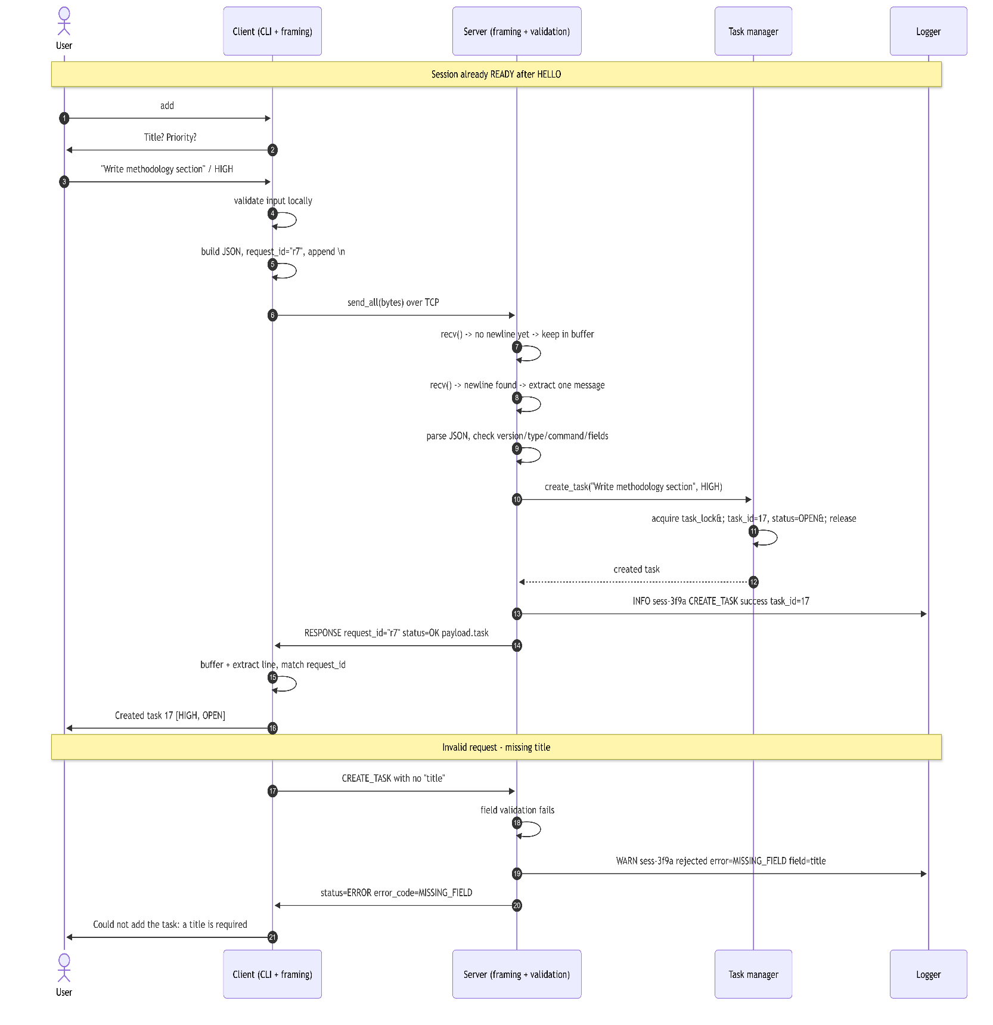

6.2 Phase 3 conflict - two clients claim the same task
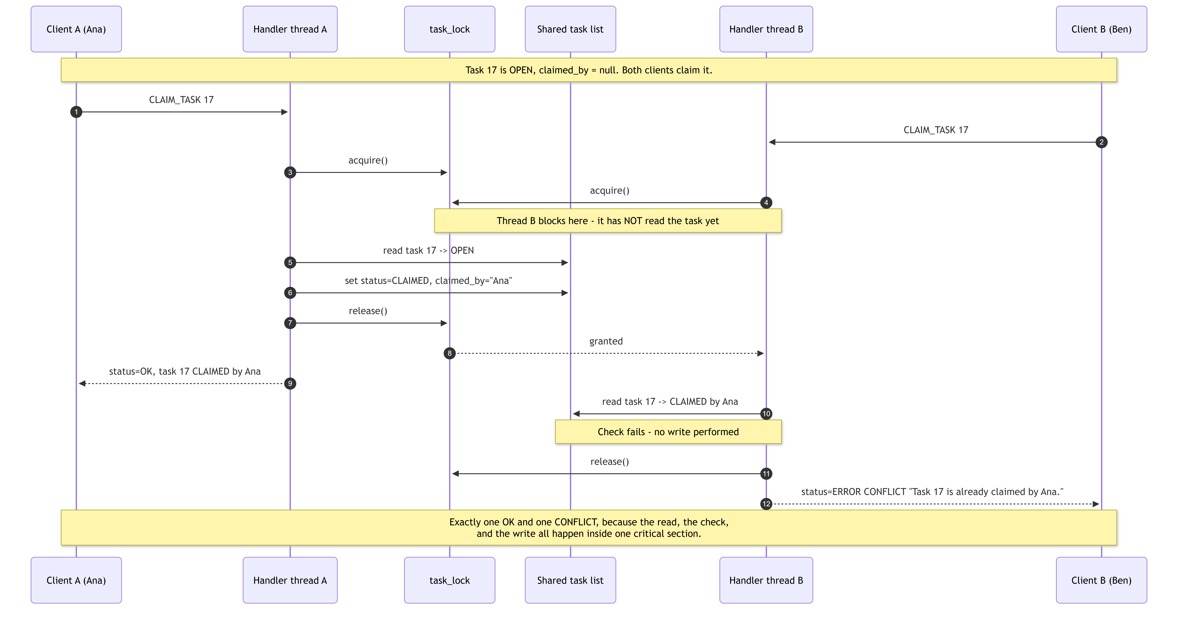

7. Protocol Specification - STCS - P1

7.1 Framing
TCP is a byte stream rather than a message stream. It maintains the byte sequence, but it cannot indicate the start and end boundaries of each application-level message. One send () could be received through multiple recv () calls and multiple send () calls could be received within a single recv () call. Hence, there is no correspondence between one send () and one recv (). It would not be possible to use delays or sleep () for framing messages.
Framing rule one message = one json object, encoded as UTF-8, containing no raw newline, followed by exactly one \n byte.
- Each message is a json object the newline terminates one logical message.
- The receiver keeps a byte buffer every recv () appends to it.
- Incomplete data stays in the buffer - nothing is processed until a \n arrives.
- Complete lines are extracted and parsed one at a time.
- If one recv () contains several complete lines, they are processed sequentially in arrival order and any trailing fragment stays buffered.
buffer = b""
loop
chunk = recv(4096)
if chunk is empty peer closed -> end session
buffer += chunk
while b"\n" in buffer
line, buffer = buffer.split(b"\n", 1) # first newline only
if len(line) > 8192 send MESSAGE_TOO_LARGE continue
if line is blank send INVALID_MESSAGE continue
handle(line)

UTF-8 data transmission with addition of one newline and loop until all the bytes are transmitted (send () may transmit less data than asked).
Use of a plain newline to separate messages in a JSON string will result in splitting one message in two unreadable chunks. In JSON, newlines inside strings should be represented as \n. Therefore, JSON serializer should be used instead of a mere concatenation of strings.

One more option was length prefix framing (length is 4 bytes long and then payload follows). It is more reliable method when dealing with binary data and no escape is needed. However, it wasn’t selected since each STCS message is a small piece of JSON text and therefore, newline framing is readable over the wire.

7.2 Encoding and limits
Property | Value
Encoding | UTF-8, no BOM
Delimiter | \n (a single trailing \r is stripped if present)
Max message size | 8192 bytes per line
Receive chunk | 4096 bytes
Timestamps | ISO-8601 UTC, e.g. 2026-03-14T142207Z

If the length of the line exceeds 8192 bytes, the server will not parse it. The response sent by the server in this case is MESSAGE_TOO_LARGE, which discards all bytes from the first byte of the current message until the next newline and hence resets the stream.

7.3 Message envelope
Request
Field | Type | Required | Notes
version | integer | yes | 1
type | string | yes | "REQUEST"
request_id | string | yes | Client-generated, unique per session, echoed back unchanged
command | string | yes | One of the commands in 7.5
payload | object | yes | {} if the command takes no arguments

Response - same version, type "RESPONSE", the echoed request_id and command, plus status ("OK" or "ERROR"), payload and - only when status is "ERROR" - error_code and a human-readable message.
{"version"1,"type""REQUEST","request_id""r7","command""CREATE_TASK","payload"{"title""Write methodology section","priority""HIGH"}}
{"version"1,"type""RESPONSE","request_id""r7","command""CREATE_TASK","status""OK","payload"{"task"{"task_id"17,"title""Write methodology section","priority""HIGH","status""OPEN","claimed_by"null,"created_by""Ana","created_at""2026-03-14T142207Z"}}}
{"version"1,"type""RESPONSE","request_id""r8","command""CREATE_TASK","status""ERROR","error_code""MISSING_FIELD","message""Field 'title' is required.","payload"{"field""title"}}
Messages must be sent on one line - the pretty-printed form above is for reading only.
- Versioning version 1. If there is no field in the packet, then the server returns "MISSING_FIELD". If the version number is unsupported, it returns "INVALID_VERSION" and the supported versions list. Additional fields and commands do not imply the version increment. Changes in definitions of fields, removal of some of them or changes in the framing implies version 2.
- Request IDs are generated by the client (for instance, "r7", counter or UUID). They are unique within each session and returned from the server without any modification to link the response to its corresponding request. The "request_id" field is set to null in the response only in case of failure to retrieve it (incorrect JSON parsing). It simplifies the logs and testing and allows handling of out-of-order responses.
- Notifications: in the first version of the protocol there is no need for unsolicited server notifications. Each server message corresponds to one request from the client. Clients can see the changes made by other clients by using LIST_TASKS command. Push may be introduced in future as a special "EVENT" message without request_id and the queue of writes per socket.Clients are supposed to ignore all messages that have unknown message type.

7.4 Session states
State | Legal commands
DISCONNECTED | none (no socket)
CONNECTED | HELLO, HELP, QUIT - anything else returns INVALID_STATE
READY | all task commands, HELP, QUIT (a second HELLO returns INVALID_STATE)
CLOSING > CLOSED | none socket closed and session released

CONNECTED > HELLO > READY > commands > QUIT > CLOSING > CLOSED. A failed HELLO leaves the session in CONNECTED so the user can retry with a different name. An INVALID_STATE error never closes the connection.

7.5 Commands
The Task entity in every message contains these attributes: task_id (integer), title (string), priority ("LOW", "MEDIUM", "HIGH"), status ("OPEN", "CLAIMED", "DONE"), claimed_by (string or NULL), created_by (string) and created_at (ISO-8601 string).

There may be errors with any command that are not included below: INVALID_MESSAGE, INVALID_VERSION, MISSING_FIELD (envelope),

1. HELLO
Purpose | Initializes the session and registers a display name.
When | CONNECTED
Fields | Required - display_name - string, 1-24 characters, letters/digits/space/_/-/., must not already be in use.  Optional - none
Returns | session_id (string), display_name, server_version (1), commands (array)
Errors | INVALID_FIELD, NAME_IN_USE, INVALID_STATE, INVALID_VERSION
Request:
{"version":1,"type":"REQUEST","request_id":"r1","command":"HELLO","payload":{"display_name":"Ana"}}
Success response:
{"version":1,"type":"RESPONSE","request_id":"r1","command":"HELLO","status":"OK",
"payload":{"session_id":"sess-3f9a","display_name":"Ana","server_version":1,
"commands":["HELLO","HELP","LIST_TASKS","CREATE_TASK","CLAIM_TASK","RELEASE_TASK",
"COMPLETE_TASK","DELETE_TASK","QUIT"]}}
Error response:
{"version":1,"type":"RESPONSE","request_id":"r1","command":"HELLO","status":"ERROR",
"error_code":"NAME_IN_USE","message":"The display name 'Ana' is already in use.",
"payload":{"field":"display_name"}}

2. HELP
Purpose | Returns the server's command list with usage text.
When | CONNECTED, READY
Fields | Required - none  Optional - command - string. Returns detail for one command only.
Returns | commands (array of objects: name, summary, required_fields)
Errors | INVALID_FIELD (unknown command name)
Request:
{"version":1,"type":"REQUEST","request_id":"r2","command":"HELP","payload":{}}
Success response:
{"version":1,"type":"RESPONSE","request_id":"r2","command":"HELP","status":"OK",
"payload":{"commands":[{"name":"CREATE_TASK","summary":"Add a task to the shared list.",
"required_fields":["title"]},{"name":"CLAIM_TASK","summary":"Take ownership of an OPEN task.",
"required_fields":["task_id"]}]}}

Error response:
{"version":1,"type":"RESPONSE","request_id":"r2","command":"HELP","status":"ERROR",
"error_code":"INVALID_FIELD","message":"Unknown command name 'ARCHIVE'.","payload":{"field":"command"}}

3. LIST TASKS
Purpose | Returns the shared task list - the basis of cross-client visibility.
When | READY
Fields | Required - none  Optional - status - one of OPEN, CLAIMED, DONE. Filters the returned list.
Returns | tasks (array of Task, ascending task_id), count (integer)
Errors | INVALID_FIELD, INVALID_STATE
Request:
{"version":1,"type":"REQUEST","request_id":"r3","command":"LIST_TASKS","payload":{"status":"OPEN"}}
Success response:
{"version":1,"type":"RESPONSE","request_id":"r3","command":"LIST_TASKS","status":"OK",
"payload":{"tasks":[{"task_id":17,"title":"Write methodology section","priority":"HIGH",
"status":"OPEN","claimed_by":null,"created_by":"Ana","created_at":"2026-03-14T14:22:07Z"}],
"count":1}}
Error response:
{"version":1,"type":"RESPONSE","request_id":"r3","command":"LIST_TASKS","status":"ERROR",
"error_code":"INVALID_FIELD","message":"Field 'status' must be OPEN, CLAIMED, or DONE.",
"payload":{"field":"status"}}

4. CREATE TASK
Purpose | Adds a task to the shared list.
When | READY
Fields | Required - title - string, 1-120 characters after trimming, not blank.  Optional - priority - LOW, MEDIUM, or HIGH. Default MEDIUM.
Behaviour | Server sets task_id from a counter, status="OPEN", claimed_by=null, created_by = session name, created_at = now.
Returns | task (full Task object)
Errors | MISSING_FIELD, INVALID_FIELD, INVALID_STATE
Request:
{"version":1,"type":"REQUEST","request_id":"r7","command":"CREATE_TASK","payload":{"title":"Write methodology section",
"priority":"HIGH"}}
Success response:
{"version":1,"type":"RESPONSE","request_id":"r7","command":"CREATE_TASK","status":"OK",
"payload":{"task":{"task_id":17,"title":"Write methodology section","priority":"HIGH",
"status":"OPEN","claimed_by":null,"created_by":"Ana","created_at":"2026-03-14T14:22:07Z"}}}
Error response:
{"version":1,"type":"RESPONSE","request_id":"r8","command":"CREATE_TASK","status":"ERROR",
"error_code":"MISSING_FIELD","message":"Field 'title' is required.","payload":{"field":"title"}}

5. CLAIM TASK
Purpose | Takes visible ownership of a task so others do not duplicate the work.
When | READY
Fields | Required - task_id - integer >= 1. Must exist and status must be exactly OPEN.  Optional - none
Behaviour | Inside one critical section: re-read the task, check status == "OPEN", then set status="CLAIMED" and claimed_by = session name.
Returns | task (full Task object)
Errors | MISSING_FIELD, INVALID_FIELD, NOT_FOUND, CONFLICT (already claimed or done - payload reports the current status and owner), INVALID_STATE

Request:
{"version":1,"type":"REQUEST","request_id":"r4","command":"CLAIM_TASK","payload":{"task_id":17}}
Success response:
{"version":1,"type":"RESPONSE","request_id":"r4","command":"CLAIM_TASK","status":"OK",
"payload":{"task":{"task_id":17,"title":"Write methodology section","priority":"HIGH",
"status":"CLAIMED","claimed_by":"Ana","created_by":"Ana","created_at":"2026-03-14T14:22:07Z"}}}
Error response:
{"version":1,"type":"RESPONSE","request_id":"r5","command":"CLAIM_TASK","status":"ERROR",
"error_code":"CONFLICT","message":"Task 17 is already claimed by Ana.","payload":{"task_id":17,
"status":"CLAIMED","claimed_by":"Ana"}}

6. RELEASE TASK
Purpose | Returns a claimed task to OPEN so someone else can take it, including when the claimant has gone inactive.
When | READY
Fields | Required - task_id - integer. Must exist and status must be CLAIMED.  Optional - none. Any session may release any claimed task (open question Q2); the releasing user is logged.
Returns | task (full Task object), released_by (string)
Errors | MISSING_FIELD, INVALID_FIELD, NOT_FOUND, CONFLICT (not claimed), INVALID_STATE
Request:
{"version":1,"type":"REQUEST","request_id":"r6","command":"RELEASE_TASK","payload":{"task_id":17}}
Success response:
{"version":1,"type":"RESPONSE","request_id":"r6","command":"RELEASE_TASK",
"status":"OK","payload":{"released_by":"Ben","task":{"task_id":17,"title":"Write methodology section",
"priority":"HIGH","status":"OPEN","claimed_by":null,"created_by":"Ana","created_at":"2026-03-14T14:22:07Z"}}}
Error response:
{"version":1,"type":"RESPONSE","request_id":"r6","command":"RELEASE_TASK",
"status":"ERROR","error_code":"CONFLICT","message":"Task 17 is not claimed, so it cannot be released.",
"payload":{"task_id":17,"status":"OPEN"}}

7. COMPLETE TASK
Purpose | Marks work finished so the remaining-work view stays accurate.
When | READY
Fields | Required - task_id - integer. Must exist and status must be OPEN or CLAIMED.  Optional - none
Behaviour | Server sets status="DONE" and keeps claimed_by as the record of who did the work.
Returns | task (full Task object)
Errors | MISSING_FIELD, INVALID_FIELD, NOT_FOUND, CONFLICT (already done), INVALID_STATE
Request:
{"version":1,"type":"REQUEST","request_id":"r7","command":"COMPLETE_TASK",
"payload":{"task_id":17}}
Success response:
{"version":1,"type":"RESPONSE","request_id":"r7","command":"COMPLETE_TASK",
"status":"OK","payload":{"task":{"task_id":17,"title":"Write methodology section",
"priority":"HIGH","status":"DONE","claimed_by":"Ana","created_by":"Ana","created_at":"2026-03-14T14:22:07Z"}}}
Error response:
{"version":1,"type":"RESPONSE","request_id":"r7","command":"COMPLETE_TASK",
"status":"ERROR","error_code":"CONFLICT","message":"Task 17 is already marked done.",
"payload":{"task_id":17,"status":"DONE"}}

8. DELETE TASK
Purpose | Permanently removes an obsolete task so the list stays trustworthy.
When | READY
Fields | Required - task_id - integer. Must exist. Any status may be deleted; the ID is never reused.  Optional - none
Returns | task_id (integer), deleted (true)
Errors | MISSING_FIELD, INVALID_FIELD, NOT_FOUND, INVALID_STATE
Request:
{"version":1,"type":"REQUEST","request_id":"r8","command":"DELETE_TASK","payload":{"task_id":18}}
Success response:
{"version":1,"type":"RESPONSE","request_id":"r8","command":"DELETE_TASK","status":"OK",
"payload":{"task_id":18,"deleted":true}}
Error response:
{"version":1,"type":"RESPONSE","request_id":"r8","command":"DELETE_TASK","status":"ERROR",
"error_code":"NOT_FOUND","message":"No task exists with id 18.","payload":{"task_id":18}}

9. QUIT
Purpose | Ends the session gracefully so the server can log a clean disconnect and release resources.
When | CONNECTED, READY
Fields | Required - none  Optional - reason - string, logged only.
Behaviour | Server sends the response, logs a graceful disconnect, closes the socket, releases the session and keeps listening. Claims held by the session remain (open question Q2).
Returns | message (string), session_id (string)
Errors | None if the message parses. A malformed QUIT still receives a structured error, shown below.
Request:
{"version":1,"type":"REQUEST","request_id":"r9","command":"QUIT","payload":{}}
Success response:
{"version":1,"type":"RESPONSE","request_id":"r9","command":"QUIT","status":"OK",
"payload":{"message":"Session closed.","session_id":"sess-3f9a"}}
Error response:
{"version":1,"type":"RESPONSE","request_id":null,"command":null,"status":"ERROR",
"error_code":"MISSING_FIELD","message":"Field 'type' is required.","payload":{"field":"type"}}

7.6 Error codes
Code | Meaning / when generated | Client behaviour
INVALID_MESSAGE | Not valid UTF-8 JSON, not a JSON object, or an empty line | Report that the message could not be understood don't resend unchanged
INVALID_VERSION | version is a value the server doesn't support | Show the supported versions retry HELLO or exit
UNKNOWN_COMMAND | command is not in the documented set | Show the command and suggest help session continues
MISSING_FIELD | An envelope or payload field is absent | Prompt for the named field and resend
INVALID_FIELD | A field has the wrong type, length, or value | Explain the constraint, re-prompt, resend
NOT_FOUND | The task_id does not exist | Say the task no longer exists suggest list
CONFLICT | Well-formed, but conflicts with current state claiming a non-OPEN task, releasing an unclaimed task, completing a DONE task | Show the current owner/status let the user choose another task. This is the normal outcome of a lost race, not a fault
INVALID_STATE | The command isn't legal in the session's current state (e.g. before HELLO) | Send HELLO first connection stays open
NAME_IN_USE | The display name is held by another active session | Prompt for a different name and retry
MESSAGE_TOO_LARGE | A line exceeded 8192 bytes | Shorten the input and resend the stream resynchronizes
SESSION_ERROR | The session cannot continue (stream desynchronized, session terminated) | Report and close a new connection may be attempted
SERVER_ERROR | An unexpected server-side failure on an otherwise valid request | Report that the request couldn't be completed and retry detail is logged server-side only

No error message contains a stack trace, file path, line number, or internal identifier. Note the distinction NOT_FOUND means the task doesn't exist CONFLICT means it exists but isn't in a state that allows the operation.

8. Data Design
Task - server-owned, shared, mutable
Field | Type | Mutable | Validation
task_id | integer ≥ 1 | No (identity) | Server-assigned from a counter never reused
title | string | No in this version | 1-120 chars, not blank, no control characters
priority | enum string | No in this version | Exactly LOW, MEDIUM, or HIGH default MEDIUM
status | enum string | Yes (claim / release / complete) | Exactly OPEN, CLAIMED, or DONE
claimed_by | string or null | Yes (claim / release) | Display name of the claiming session, or null preserved when the task becomes DONE
created_by | string | No | Display name of the creating session
created_at | ISO-8601 string | No | Server clock at creation

status transitions - anything else returns CONFLICT and leaves the record unchanged
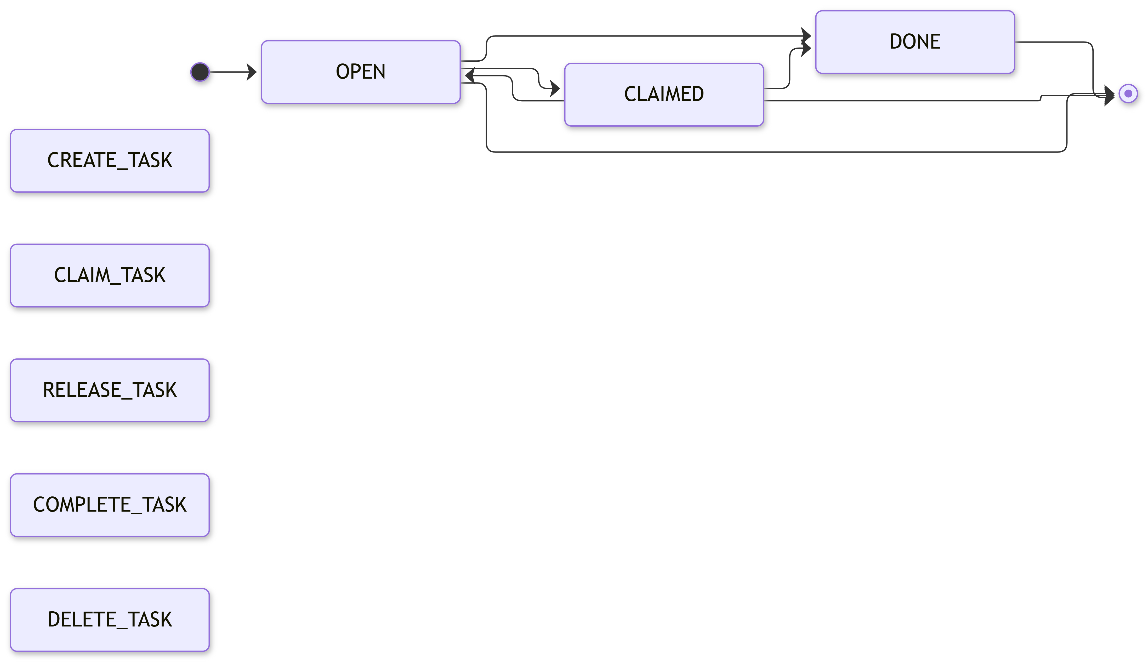
claimed_by and created_by store a display name, not a session reference, so a task stays meaningful after that session ends.
Other data structures

Structure | Owned by | Contents | Sharing and locking
TaskStore | Server (shared) | tasks - map of task_id → Task (O(1) lookup, needed by every command except LIST_TASKS)  next_task_id - integer counter  task_lock - one mutex guarding both | Every access goes through task_lock, so two concurrent creates can never receive the same ID.
ClientSession | Created by the accept loop, then owned by one handler thread | session_id - string, unique, immutable  display_name - string, set once at HELLO, unique among active sessions  socket, peer_address (logged)  state - CONNECTED / READY / CLOSING / CLOSED  recv_buffer - bytes, bounded at 8 KiB  connected_at | Socket, buffer and state are touched by exactly one thread, so they need no synchronization. This is why one lock suffices for the whole server.
SessionRegistry | Server (shared) | sessions - map of session_id → ClientSession | Guarded by session_lock. Used for the display-name uniqueness check, session-tagged logging and shutdown. Never acquired while task_lock is held, or vice versa.
Client-side state | Client process | ClientConfig - host, port, display_name  SessionState - state, session_id, next request counter  recv_buffer - bytes | The client holds no task list. Every display comes straight from the response that produced it.

Shared state and locking
Data | Shared | Mutated by | Read by | Lock
tasks, next_task_id | Yes | CREATE_TASK, CLAIM_TASK, RELEASE_TASK, COMPLETE_TASK, DELETE_TASK | LIST_TASKS | task_lock on every access, read or write
sessions | Yes | connect, disconnect | Hello name check, shutdown | session_lock
Log sink | Yes | every log write | - | serialized logger
Session socket, buffer, state | No | its own thread | - | none

Reads take the lock too an unlocked read could see a task whose status is already CLAIMED but who’s claimed_by hasn't been written yet and report it to a user.

The dangerous pattern is a check-in-the-act split across a lock boundary
task = store.get(17) lock acquired and released
if task.status == "OPEN" another thread can claim right here
store.claim(17, me) lock acquired again

Both threads could read OPEN, both pass the check and the second write silently overwrites the first - two people believing they own task 17, which is exactly the failure the product exists to prevent.

Two clients want to claim task 17 (OPEN) simultaneously:

- Both handlers make task_manager.claim(17, session) and do nothing special for the locks.
- The Task Manager acquires the task_lock, the losing thread waits until the task is read.
- In the critical section, it re-reads the task 17. If its status is "OPEN", the status is changed to "CLAIMED" and claimed_by is set to the real client.
- After that, the Task Manager releases the lock, returns the response and logs the information outside the lock.
- One of the clients receives OK and becomes the task owner, the other one receives CONFLICT and knows who the owner is (exactly one owner is possible). In other words, the owner is chosen by OS scheduler and both responses are right. The loser knows the owner. It will be tested 20 times by T-11.

Tasks live in RAM longer than any client session; they do not persist to the disk as it is hard to achieve atomicity and prevent corruption of the filesystems which will lead to the problem with framing and concurrency. In case of the server crash, all tasks will be lost, and the clients will be informed about the loss of the connection. To save the data for later use (open question Q1), append one line per change in JSON format to the data/tasks.jsonl file after releasing the lock.

9. Initial Test Plan
No code exists yet, so every Actual Result is Not yet executed and every status is Planned. No framing test uses sleep () or any timing delay - splits are produced by controlling the writes directly.
ID | Requirement | Initial conditions | Input / action | Expected result | Actual | Pass/Fail
T-01 | FR-01, FR-02, FR-04, FR-05 | Server on port 5050, no clients | Start client on 127.0.0.1:5050, name Ana, send HELLO | Connection established OK with a non-empty session_id, server_version 1, command list state READY log records the connection | Not yet executed | Planned
T-02 | FR-06, FR-12 | T-01 done list empty | add > title Write methodology section, priority HIGH | OK task_id 1, status "OPEN", claimed_by null, created_by "Ana", timestamp set log records success | Not yet executed | Planned
T-03 | FR-07, FR-26 | Three tasks exist one OPEN, one CLAIMED, one DONE | list, then list with status=OPEN | Unfiltered three tasks by ascending task_id with all fields, count 3. Filtered only the OPEN task, count 1 | Not yet executed | Planned
T-04 | FR-08, FR-10, FR-11, FR-18, FR-24 | Tasks 1 and 2 exist, both OPEN | claim 1 release 1 claim 1 done 1 done 1 again delete 2 list quit | Claim OK, CLAIMED by Ana. Release OK, back to OPEN. Done OK, DONE, claimed_by kept. Second done CONFLICT. Delete OK task 2 gone from list. quit OK, clean exit, graceful-disconnect log entry | Not yet executed | Planned
T-05 | FR-14, NFR-01 | Session READY | Raw client sends command "MAKE_COFFEE", then a valid LIST_TASKS on the same connection | First ERROR / UNKNOWN_COMMAND, connection open, server alive. Second OK with the list - the session survived | Not yet executed | Planned
T-06 | FR-15, FR-16, FR-17, NFR-06 | Session READY one task exists | (a) CREATE_TASK with no title (b) priority "URGENT" (c) task_id "abc" (d) task_id 999 (e) {"version"1, + newline (f) an empty line | (a) MISSING_FIELD naming title (b) and (c) INVALID_FIELD naming the field (d) NOT_FOUND (e) and (f) INVALID_MESSAGE. Connection stays open throughout list afterwards still shows exactly one task no response contains a stack trace or file path | Not yet executed | Planned
T-07 | FR-03, NFR-09 | Server not running | Start the client on 127.0.0.15050 | Plain-language failure ("Could not connect - is the server running?") no traceback gives up within 10 s | Not yet executed | Planned
T-08 | FR-03, NFR-09 | Server running | (a) host not.a.real.host.invalid (b) port 70000 (c) port abc | (a) unresolvable-host message (b) and (c) rejected by client-side validation before any socket is created, with a message stating the valid range 1-65535. No crash, no hang | Not yet executed | Planned
T-09 | FR-19, NFR-02 | Client READY, one task created | Kill the client process without sending QUIT then start a new client and list | Server's recv returns zero bytes server logs an abrupt disconnect, closes the socket, removes the session, keeps listening to the new client connects and sees the task created by the dead session | Not yet executed | Planned
T-10 | FR-13, FR-20, NFR-10 | Server running, no clients | Connect three clients (Ana, Ben, Cara) Ana adds a task and claims it Ben and Cara then list (without reconnecting) | All three HELLOs succeed with distinct session IDs all three-stay connected Ben and Cara both see the task as CLAIMED by Ana, proving one authoritative copy and no client caching | Not yet executed | Planned
T-11 | FR-08, FR-09, NFR-03 | Task 17 exists; OPEN two scripted clients hold pre-built CLAIM_TASK requests | Release both writes as simultaneously as possible (threads released by a barrier, not by delays). Repeat 20 times with a fresh OPEN task each trial | Every trial is exactly one OK (that client shown as claimed_by) and exactly one CONFLICT naming the actual owner. Final record has exactly one owner, never null, never both. Log shows one success and one conflict per trial | Not yet executed | Planned
T-12 | FR-21, NFR-02 | Three clients READY | Ben streams 50 malformed lines (truncated JSON, unknown commands, one 20 KiB line) while Ana and Cara each issue 10 valid commands | Ben gets a structured error per line and his session stays open Ana and Cara get correct responses to all 20 commands server process alive task list consistent log entries complete and tagged to the right session | Not yet executed | Planned
T-13 | 7.1 framing - partial message | Framing module under unit test, plus a raw socket client. One valid CREATE_TASK serialized to bytes | Unit test feed the bytes to the framer one byte at a time. Socket test send all but the last 10 bytes, then the rest including the \n, in two send() calls with no delay. Repeat with a split inside a multi-byte UTF-8 character | Framer emits zero messages until the byte containing \n is fed, then exactly one complete message with the right content. Over the socket, the server processes it once one OK, one log entry, one task created | Not yet executed | Planned
T-14 | 7.1 framing - two messages in one read | Framing module under unit test, plus a raw socket client. Session READY, list empty | Concatenate two complete framed messages - CREATE_TASK("A")\nCREATE_TASK("B")\n - into one send (). Then repeat with two complete messages plus a trailing fragment CREATE_TASK("C") with no newline | Framer returns both messages in arrival order from one feed. Server sends two responses, both OK, request_ids matching each request both tasks exist with distinct IDs. In the second case exactly two tasks are created and the fragment stays buffered until its newline arrives - no third task, no error, no data loss | Not yet executed | Planned

Coverage 4 normal-operation tests (T-01-T-04), 2 invalid-input tests covering 8 cases (T-05, T-06), 3 networking-failure tests (T-07-T-09), 2 framing tests (T-13, T-14), 3 concurrency tests (T-10-T-12).

10. Contribution Plan (Individual)
Work area | Ownership | Phase
Problem research and user evidence | Individual | 1
Requirements (functional and nonfunctional) | Individual | 1
Architecture and concurrency design | Individual | 1
Protocol design and specification | Individual | 1
Data design | Individual | 1
Test planning | Individual | 1
Framing layer and protocol module | Individual | 2
Server implementation (listener, session, validation, application, task store) | Individual | 2
Client implementation (CLI, validation, connection, display) | Individual | 2
Error handling and logging | Individual | 2
Concurrency and synchronization | Individual | 3
Testing and test report | Individual | 2-3
Documentation and demonstration | Individual | 1-3

